18.53:

So the total change in volume is b) Yes; 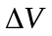 is much less than the original volume of 